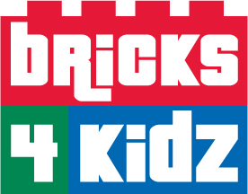
Motor Mania
At Meadow Drive School!

Tuesdays – Grades K-2
September: 24 October: 8, 15, 22, 29
and November: 12, 19, 26
Classes are from 2:50-4:00pm
Room: TBA
$180 per child; 1 hour session per week for 8 weeks
Registration is limited to 10 children
Please make checks payable to Bricks 4 Kidz
Please register no later than Friday, September 20th or a $25 dollar late fee will be applied.

Bricks4Kidz™ after school classes build on the popular LEGO® bricks to deliver high-quality educational play. Each hour-long class is an engaging experience for your child with a new project each week. Our unique models aren’t the kits you find on the shelves of a toy store. They’re designed by Bricks4Kidz™ to teach concepts across a variety of subject areas. We kick things off with a discussion about key concepts related to the model, then get right into the building. Working with a partner, your child will experience the hands-on fun of seeing a model come together piece-by-piece, from concept to completion – and it’s motorized!

- - - - - - - - - - - - - - - - - - - - - - - - - - - -
Bricks 4 Kidz Fall 2019

Child’s Name: _____________________________________________________

Teacher: ________________________________________________________

Emergency Contact Name: ___________________________________________

Emergency Contact Phone Number: ____________________________________

Person authorized to pick child up in the event that the parent/guardian is unavailable:

(Name) _______________________________ (Phone#) __________________

Parent’s Signature: ________________________________________________

