YOGA FOR KIDS at Meadow Drive
Children derive enormous benefits from yoga. This class will introduce your kids to yoga in a simple, fun and playful way! Here are just some of the benefits of practicing yoga:
Introduces kids to mindfulness •Builds confidence •Improves concentration
•Helps kids manage stress through breathing •Promotes a healthy body
•Improves coordination and balance
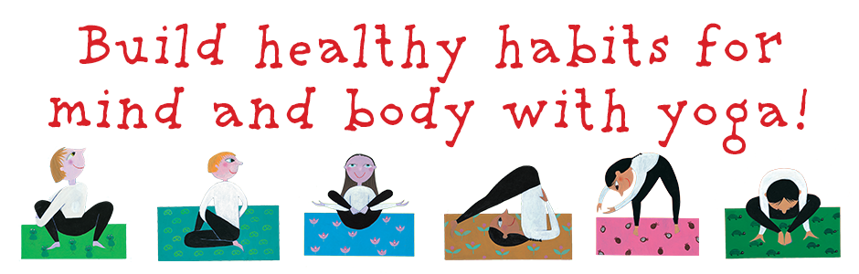

8 sessions  Mondays  2:50pm to 4:00pm
September 23, October 7, 21, 28, Nov 4, 18, 25, Dec 2
Cost: $160
Registration is limited to 10 children on a first come, first served basis.
Please make checks payable to Cindy Zameryka.

Cindy Zameryka is a former elementary school teacher specializing in deaf education, certified in Bikram, kids and family yoga, former teacher @On Track Wellness, conducts private and small group yoga classes and a mom of 2 Mineola students.
If you have any questions, please contact me at cindy.zameryka@gmail.com
- - - - - - - - - - - - - - - - - - - - - - - - - - - - - - - - - - - - - - - - - - - - - - - - - - - - - - - - - - - - - - - -
Child’s Name: __________________________________________________
Teacher: _______________________________________________________
Parent name: ___________________________________________________
Parent phone number & email ____________________________________
Emergency Contact/Person authorized to pick child up in the event that the parent/guardian is unavailable: Name____________________________________________________________
Phone Number ___________________________________________________
Parent’s Signature_________________________________________________
Yoga for Kids

