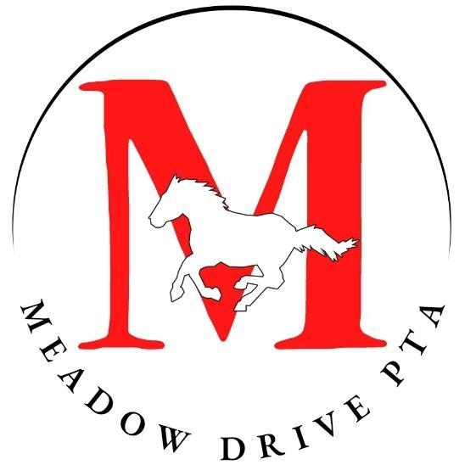

The Parent Teacher Association’s mission is to make every child's potential a reality by engaging and empowering families and communities to advocate for all children.

Help us make our community better!

Meeting Agenda ~ September 15, 2022 @ 6:00PM (Cafeteria)
Sign In
- Call to Order- Meeting Called to Order 6:06PM
  - Pledge of Allegiance
  - Introduction to the PTA/Background of PTA and instructions to sign in
- President’s Report - Sofia Palominos (MeadowDrPTA@gmail.com)
  - Welcome Back Events:
  - Supply Drop- went well and families felt welcome
  - Popsicles on the Playground for Pre K and K families
  - Chalk the Walk-rescheduled due to weather but was well received
  - BooHoo Yahoo Bags
  - Staff Breakfast-put on breakfast went well, staff was very grateful
- Vice Presidents’ Report - Katie Thelian and Katherine Bennett (MeadowDrPTAVP@gmail.com)
  - Chairpersons needed for various Committees and Events,
  - Sign up Binder
  - Need volunteers for Welcome back BBQ, Need chairs for Reflections, and Fall Festival
  - please see the reverse side for more details.
- Recording Secretary’s Report - Christina Finn (MeadowDrPTARecSec@gmail.com)
Reminder to sign in
- Treasurer’s Report - Ryan McHale
Budget available for review
PNO biggest fundraiser
Budget Approved- Amy Levine and Angie Batista
- Corresponding Secretary’s Report - Kristina Pisciotta
Link to google calendar reviewed
- Committee Reports:
  - Class Parent Coordinator - Deanna Schuler Lottery is being held on Wednesday. Missing a volunteer for Ms. Miller’s class. Direct questions to Deanna.
  - Hospitality - Alecia Pace and Katie Dugan Introduction to the committee
  - Membership - Megan Romito and Susan Walsh membership goal of 363 members. Meadow Drive has a very high goal. 211 members. Plan to add membership incentives. Black Friday give away,
  - Memory Book - Christina Mouroulis (MeadowDrMemories@gmail.com) Take lots of pictures to contribute to memory book
  - National PTA School of Excellence - Jill Pigott, Caitlin Moronta and Christina Finn (MeadowDrExcellence@gmail.com) Centered around family engagement or health. Involves filling out surveys. Have been awarded School of Excellence 2 years in a row. Only 5 schools on Long Island and 14 in the state.
- Past Events
  - School Supplies - Lisa Pullows (MeadowDrSupplies@gmail.com) We sold a total of 63 boxes. 1st grade had the most sales. Our total fundraising profit was $506.
- School Toolbox Report
  - Summer Reading - Eileen Blanco Lots of participants. Prizes available for weekly raffles. No chair for summer reading 2023.
- Current and Upcoming Events
  - Book Fair (until Saturday) - Anyis Batista and Evelyn Matranga
120 people signed up for e-wallets. Runs until Saturday. Direct any questions to Angie
Welcome Back BBQ (Saturday, Sept. 17 from 1:00-3:00PM) - Katherine Bennett still need volunteers and DA will present to provide safe child IDS.
  - Playground Playdate (Saturday, Oct. 8 at 9:00AM) - Lisa Pullows (MeadowDrPTAPlaydates@gmail.com)
it will be at 9:00 in the school playground and it will be a chance for kids and parent to meet and play and help get the float ready for Homecoming
  - Homecoming Parade (Saturday, Oct. 8, kick-off at 12:00PM) - Susan Walsh (MeadowDrHomecoming@gmail.com)
Sue Walsh is homecoming chair, Saturday October 8th. Unsafe for children to be on. Parents cannot repair, needs to be done by a contractor. And would need a quote. Hayride.com -rental can hold 30 people and costs 1000 dollars. Does not include cost of decorating. Proposed the idea of fire truck rental. Ms. Fahey suggested that other PTAS have parody with what Meadow Drive does. Reach out to Sue for volunteering.
  - Photo Day (Tuesday, Oct. 11) - Allison Dinkelacker Flyers will go out, in need of volunteers.
  - Walk & Roll (Wednesday, Oct. 12) - Erin Gonzalez Encourage all students to walk and roll to school. Need volunteers to hang up signs that morning,.
  - Parents’ Night Out Fundraiser (Saturday, Oct. 22 from 7:00-11:00PM) - Melodie Kraljev -Biggest fundraiser, Halloween theme, Costume optional, has DJ, Costume contest, fun auctions, tickets available on Memberhub, still soliciting and looking for donations/sponsors.
  - Halloween Party (Monday, Oct. 31) - Teresa Smallwood and Nicole Barthelemy Dance party, wear costumes to school, more details to follow.
- Principal’s Report - Mrs. Fahey New this year: Grownup companion badge book going home this year. Bus drills today and went well. First fire drill went well yesterday. Lock down drills coming up and families will be informed. Intramurals will start October 4th for 1st and 2nd graders.
- Board of Education Report
- Teachers’ Rep Report- address to the family and thanks for the breakfast.
- SEPTA Liaison - Katy Gilroy Introduction Tentative Meet and Great October 1st at the Cornerstone. At Homecoming selling tote bags. Looking for volunteers. First Meeting October 12th.
- Closing Remarks/Meeting adjourned 6:57 Meeting adjourned.

📣We are in need of volunteers to Chair/Co-Chair the following Committees and Events:

Advocacy  (Can be done from home.) | Advocate for the children in our school community and keep track of initiatives at the state and national levels.
Assemblies/Cultural Arts* | Coordinate cultural arts assemblies for the students to experience during the school day. This may require limited in-school time (check assembly set-up and vendor arrival), but mostly can be done from home.
Online Fundraising  (Can be done from home.) | Promote these online shopping options (AmazonSmile, Oliver’s Labels and Box Tops) various times throughout the year.
Online Store Manager  (Can be done from home.) | Work with the spirit wear company (Squadlocker) to maintain the Meadow Drive PTA online store, manage the in-stock orders received through the Memberhub Store and promote sales.
Procedures & Bylaws  (Can be done from home.) | Review the current Bylaws and suggest any necessary changes.
Reflections*  (Can be done from home.) | Promote this NYS PTA Contest, get families excited to participate, work with volunteers to judge the entries and coordinate prizes for the entrants. This takes place from early October through November.
Fall Festival* | Coordinate with a local garden center and the Hampton Street PTA Chairperson. Promote the event and tend to the PTA table the day of the event. This event is tentatively Oct. 16 for a couple hours.
S.T.E.A.M. Museum | Coordinate the STEAM (Science, Technology, Engineering, Art, and Math) event with the vendor and assist the day of, if needed. (Jan 10)
Nominating Committee  (Can be done from home.) | Help identify the 2023-2024 Officers! Free training is offered to learn how important the role of the Nominating Committee is in the PTA.
Family Game Show Night | Coordinate with the vendor prior to the event and promote the event. (Feb 7)
Book Fairies | Coordinate with the nonprofit organization to determine a pick up date and time, box the books into genres/ages/etc. and ensure the boxes get picked up.
PARP  (Can be done from home.) | Work with the administration and the District PTAs to coordinate events, oversee the creation of the PARP packet, and work with the Family Reading Night Chairperson to coordinate a common theme.
Family Reading Night  (Can be done from home.) | Coordinate with the administration, the PARP Chairperson and possibly a vendor to create a fun family event that celebrates reading together. This event will be virtual in March during PARP.
PTA Awards | Solicit and review nominations for awards that recognize PTA volunteers, teachers, staff and community members for outstanding service. Coordinate with the PTA President and the Hospitality Committee in April to present the awards to the recipients in May/June.
Summer Reading  (Can be done from home.) | Assemble the summer reading packet, organize an in-school DEAR (Drop Everything And Read) day, keep track of social media posts and reading logs, and coordinate prizes. This event runs from June-September.

Please contact MeadowDrPTAVP@gmail.com with any questions or for more information.

* This is a time sensitive Committee that usually starts planning in September/early October. If a Chairperson is not confirmed asap our learners may lose out on wonderful experiences.

“Volunteers do not necessarily have the time; they just have the heart.” ~Elizabeth Andrew

We appreciate you!

